DENSITY WORKSHEET 1
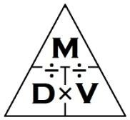
Directions: Solve the problem! Show your Work!
This is the basic problem given for understanding DENSITY. Remember that the formula for density is…
Density= ^{Mass}/_{Volume} Volume= ^{Mass}/_{Density} Mass= Density × Volume

- Mass = 40g Volume = 20mL
  - What is the Density?
- Density = 2 ^{g}/_{mL}
Volume = 20mL
  - What is the Mass?

- Mass = 35g Density = 5 ^{g}/_{cm3}
  - What is the Volume?
- Mass = 35g Volume = 7cm³
  - What is the Density?

- Density = 7 ^{g}/_{mL}
Volume = 10mL
  - What is the Mass?
- Mass = 70g Density = 7 ^{g}/_{mL}
  - What is the Volume?

- Mass = 22g Volume = 2cm³
  - What is the Density?
- Density = 11 ^{g}/_{cm3}
Volume = 2cm³
  - What is the Mass?

- Mass = 16g Density = 2 ^{g}/_{cm3}
  - What is the Volume?
- Mass = 16g Volume = 8mL
  - What is the Density?

- for SOLIDS is L×W×H = Volume
- Density = ^{Mass}/_{Volume}

- Mass = 48g

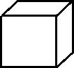
L = 2cm
W = 3cm
H = 4cm
- What is the Volume?
13. Mass = 63g
L = 1cm
W = 7cm
H = 3cm
- What is the Volume?

- What is the Density? •What is the Density?

12. Mass = 60g

L = 4cm
W = 5cm
H = 6cm
- What is the Volume?
- Mass = 16g
L = 4cm
W = 4cm
H = 4cm
- What is the Volume?

- What is the Density? •What is the Density?

- For LIQUIDS,

(Final Water Level ‐ Starting Water Level) = Volume
- Density = ^{Mass}/_{Volume}

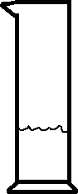
- Mass = 25g
Final: 50mL

- What is the Volume?
Start: 45mL
17. Mass = 60g

- What is the Volume?
Final: 90mL
Start: 75mL

- What is the Density? •What is the Density?

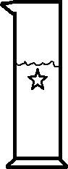
16. Mass = 10g
Final: 50mL

- What is the Volume?
Start: 30mL
18. Mass = 10g

Start: 55mL
Final: 85mL
- What is the Volume?

- What is the Density? •What is the Density?

